ONLINE PURCHASE PREDICTOR

Project Id: 21

Name : Shambhavi Srivastava (Team Leader)
Class Roll Number: 23
University Roll Number : 2028490
Section and Group: P,G1

Name : Ambika
Class Roll Number: 06
University Roll Number : 2028388
Section and Group: P,G1

Name: Tanishka Soni
Class Roll Number: 25
University Roll Number : 2028509
Section and Group: P,G1

INDEX
- Problem Description 3
- Architecture 4
- Models model 5
- Evaluation metrics used 6
- Preliminary Results and Visualizations 7
- References 8

- PROBLEM DESCRIPTION

With the emergence of e-commerce platforms, understanding customer behaviour has become very important for businesses. Many users visit online shopping websites, browse products, and view different pages, but only a small percentage of them actually end up buying something online. Predicting whether a customer will buy a product based on their browsing behaviour can help companies improve their marketing strategies, personalize recommendations, and increase sales.
The problem statement states to develop a machine learning classification system that makes predictions of whether the user makes a purchase or not based on their online browsing behavior. The dataset includes behavioral attributes such as browsing time, number of clicks, product views, session duration, and page visits. These features provide useful information about the level of customer interest in a product.
Before building the predictive model, the dataset needs to be preprocessed. This includes handling missing values, removing duplicate or irrelevant records, and applying feature scaling so that all features are in a similar range. Feature selection techniques are used to eliminate low-impact attributes and keep only the most important behavioural features that influence purchasing decisions.
After preprocessing, classification algorithms such as Logistic Regression and K-Nearest Neighbors (KNN) are applied to train the model. The performance of the model is evaluated using accuracy, precision, and F1-score to ensure reliable prediction of customer purchasing behavior.

- ARCHITECTURE:

The architecture of the Online Purchase Prediction System consists of multiple stages including data preprocessing, feature engineering, model training, prediction, and evaluation. The complete workflow ensures that the raw dataset is transformed into a suitable format for machine learning algorithms and evaluated using standard classification metrics:
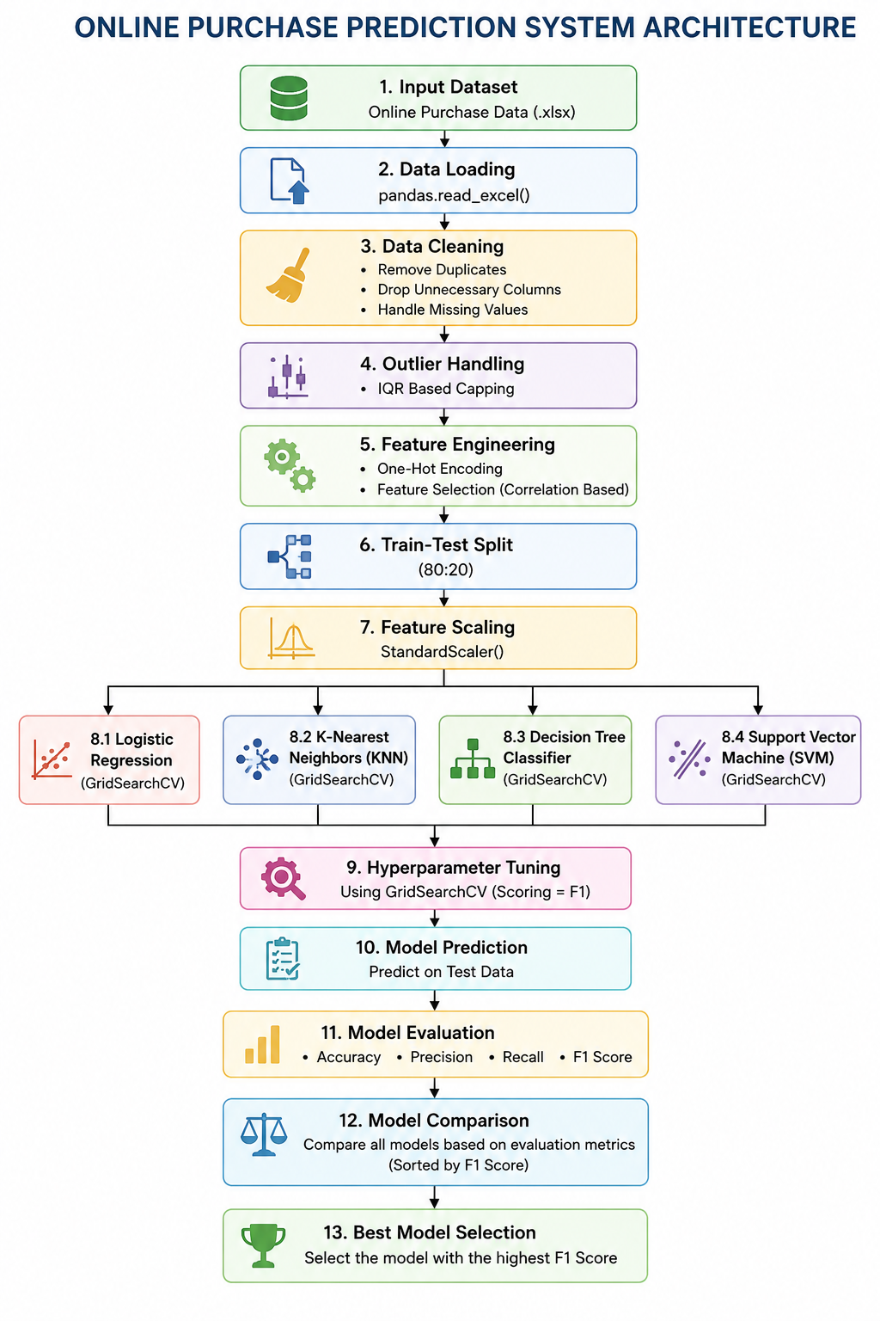
- MODELS USED:

In this project, Logistic Regression and K-Nearest Neighbours (KNN) are chosen as the primary machine learning algorithms for predicting online purchase behavior. These algorithms are selected based on their suitability for binary classification problems, interpretability, and effectiveness on behavioural datasets.
- LOGISTIC REGRESSION:
Logistic Regression is a widely used supervised learning algorithm for binary classification tasks. Since the objective of this project is to predict whether a user will make a purchase (Yes/No), Logistic Regression is a natural choice. It estimates the probability of a particular outcome using a sigmoid function, making it highly interpretable and easy to implement.
Additionally, Logistic Regression performs well when there is a linear relationship between input features and the target variable. It provides insights into feature importance, helping in understanding how different behavioral factors (such as session duration or number of clicks) influence purchasing decisions. It is also computationally efficient and works well with large datasets.
- K-NEAREST NEIGHBORS (KNN):
KNN is a non-parametric, instance-based learning algorithm that classifies data based on the similarity between data points. Unlike Logistic Regression, KNN does not assume any linear relationship between features and the target variable.
This makes KNN particularly useful for capturing complex and non-linear patterns in user behaviour. For example, users with similar browsing patterns may exhibit similar purchasing tendencies, which KNN can effectively identify using distance metrics. It is simple to understand and can perform well when the dataset has clear clusters or patterns.

- SUPPORT VECTOR MACHINE (SVM):
Support Vector Machine (SVM) is a powerful supervised learning algorithm used for both classification and regression tasks. In this project, SVM is used for binary classification to predict whether a customer will make a purchase or not.
SVM works by finding the optimal hyperplane that separates data points of different classes with the maximum margin. It is highly effective in handling high-dimensional datasets and can model both linear and non-linear relationships using kernel functions.
SVM is particularly beneficial for customer behaviour prediction because it can accurately classify users even when the data contains overlapping patterns. It also performs well with complex datasets and helps improve prediction accuracy by identifying the best decision boundary between purchasing and non-purchasing users
4. DECISION TREE:
Decision Tree is a supervised machine learning algorithm used for classification and prediction tasks. It works by splitting the dataset into smaller subsets based on feature conditions, creating a tree-like structure of decisions.
Decision Trees are easy to understand and interpret, making them useful for analysing
customer behaviour. They can handle both numerical and categorical data and do not require feature scaling. The algorithm identifies the most important behavioural attributes that influence purchasing decisions by selecting the best splitting criteria at each node.
In this project, Decision Tree helps in understanding how different browsing activities,
such as page visits, session duration, and product views, contribute to online purchasing behaviour. It is effective in capturing non-linear relationships and interaction patterns among features

- EVALUATION METRICS USED:

Evaluation metrics are essential for measuring the performance and effectiveness of machine learning models. In this project, multiple classification evaluation metrics were used to assess the predictive capability of the developed models. Since the project focuses on predicting customer purchasing behavior, relying on a single metric could produce misleading results. Therefore, a combination of Accuracy, Precision, Recall, and F1 Score was used for comprehensive model evaluation.
The evaluation process helps determine how effectively the model distinguishes between customers who are likely to make a purchase and those who are not.

1. CONFUSION MATRIX
The confusion matrix is a tabular representation used to evaluate the performance of classification models. It compares the actual class labels with the predicted class labels generated by the model.
Actual Class | Predicted Positive |  |  |  |  |  |  |  |  |  | Predicted Negative
Positive | True Positive (TP) |  |  |  |  |  |  |  |  |  | False Negative (FN)
Negative | False Positive (FP) |  |  |  |  |  |  |  |  |  | True Negative (TN)

Components of Confusion Matrix:
True Positive (TP):
The number of customers correctly predicted as purchasers.
True Negative (TN):
The number of customers correctly predicted as non-purchasers.
False Positive (FP):
The number of customers incorrectly predicted as purchasers when they are actually non-
purchasers.
False Negative (FN):
The number of customers incorrectly predicted as non-purchasers when they are actually purchasers.
The confusion matrix serves as the foundation for calculating all other evaluation metrics

2. ACCURACY
Accuracy measures the overall correctness of the model by calculating the proportion of correctly predicted observations to the total observations.
Formula:
Accuracy = (TP + TN) / (TP + TN + FP + FN)
Explanation
Accuracy indicates how often the classification model makes correct predictions. It is one of the most commonly used evaluation metrics in machine learning classification problems.
A higher accuracy value represents better model performance.
Advantages
- Simple and easy to understand
- Useful when the dataset is balanced
- Provides an overall measure of prediction capability
Limitations
Accuracy may become misleading when the dataset is imbalanced. For example, if 90% of customers do not purchase products, a model predicting all customers as non-purchasers can still achieve very high accuracy without actually learning meaningful patterns.
Importance in This Project
Accuracy provides a general overview of how effectively the model predicts customer purchasing behavior. However, due to the possibility of class imbalance, additional metrics were also considered

3. PRECISION
Precision measures the proportion of correctly predicted positive observations among all observations predicted as positive.
Formula
Precision = TP / (TP + FP)
Where:
TP = True Positive
FP = False Positive
Explanation
Precision evaluates the reliability of positive predictions generated by the model. It focuses on minimizing false positive predictions.
High precision means that when the model predicts a customer will make a purchase, the prediction is usually correct.
Advantages
- Reduces false positive errors
- Improves reliability of positive predictions
- Useful in decision-making systems
Limitations
A model may achieve high precision while missing many actual positive cases, resulting in low recall.
Importance in This Project
In online purchase prediction systems, high precision helps organizations reduce unnecessary marketing costs. It ensures promotional campaigns target customers who are genuinely likely to purchase products.
Example
If the model predicts that 100 customers will purchase a product and only 80 actually purchase it:
Precision=80100=0.80Precision = \frac{80}{100} = 0.80Precision=10080​=0.80
This indicates that 80% of positive predictions are correct.

4. RECALL
Recall measures the proportion of actual positive observations correctly identified by the model.
Formula
Recall = TP / (TP + FN)
Where:
TP = True Positive
FN = False Negative
Explanation
Recall evaluates the model’s ability to identify all relevant positive cases. It focuses on minimizing false negative predictions.
A high recall value means the model successfully identifies most customers who are likely to purchase products.
Advantages
- Reduces false negative errors
- Useful when missing positive cases is costly
- Improves detection capability
Limitations
High recall may sometimes increase false positive predictions, reducing precision.

Importance in This Project
Recall is highly important because failing to identify potential customers may lead to loss of business opportunities and reduced sales conversions.
Example
If 100 customers actually purchase products and the model correctly identifies 85 of them:
Recall=85100=0.85Recall = \frac{85}{100} = 0.85Recall=10085​=0.85
This means the model successfully detects 85% of actual purchasers.

5. F1 SCORE
F1 Score is the harmonic mean of Precision and Recall. It provides a balance between both metrics.
Formula
F1 Score = 2 × (Precision × Recall) / (Precision + Recall)
Explanation
F1 Score combines Precision and Recall into a single metric. It is particularly useful when the dataset is imbalanced and when both false positives and false negatives are equally important.
Unlike arithmetic mean, the harmonic mean penalizes extreme values. Therefore, the F1 Score becomes high only when both Precision and Recall are high.
Advantages
- Balances Precision and Recall
- Suitable for imbalanced datasets
- Provides a more realistic performance measure
Limitations
F1 Score does not consider True Negatives directly.
Importance in This Project
The project primarily uses F1 Score for:
- Hyperparameter tuning using GridSearchCV
- Final model comparison
- Best model selection
This is because F1 Score provides a balanced evaluation of customer purchase prediction performance.

6. EVALUATION METRICS USED IN THE PROJECT
The following evaluation metrics were implemented using the Scikit-learn library:

accuracy_score()
precision_score()
recall_score()
f1_score()

These metrics were calculated for all machine learning models developed in the project, including:
- Logistic Regression
- K-Nearest Neighbors (KNN)
- Decision Tree Classifier
- Support Vector Machine (SVM)

7. HYPERPARAMETER TUNING AND EVALUATION

To improve model performance, hyperparameter optimization was performed using GridSearchCV.

The scoring parameter used during tuning was:

scoring='f1'

This means the models were optimized to maximize the F1 Score.

Cross-validation was also applied during GridSearchCV to improve generalization performance and reduce overfitting.

8. MODEL COMPARISON STRATEGY
After training and testing all machine learning models, their evaluation metrics were compared systematically.
The comparison process involved:
- Training all models using training data
- Generating predictions on testing data
- Calculating Accuracy, Precision, Recall, and F1 Score
- Comparing the metric values of all models
- Selecting the best-performing model based on highest F1 Score
This approach ensured fair and comprehensive performance analysis.

9. SIGNIFICANCE OF MULTIPLE EVALUATION METRICS

Using multiple evaluation metrics provides a better understanding of model performance because each metric evaluates a different aspect of classification behavior.

Metric |  |  |  |  |  |  |  | Measures
Accuracy |  |  |  |  |  |  |  | Overall prediction correctness
Precision |  |  |  |  |  |  |  | Reliability of positive predictions
Recall |  |  |  |  |  |  |  | Ability to detect actual positives
F1 Score |  |  |  |  |  |  |  | Balance between Precision and Recall

Considering multiple metrics prevents biased conclusions and improves model reliability.

CONCLUSION
The evaluation framework implemented in this project provides a robust and comprehensive analysis of machine learning model performance. Instead of depending solely on accuracy, multiple evaluation metrics were used to capture different aspects of prediction quality.
Among all metrics, F1 Score was considered the most important because it effectively balances Precision and Recall while handling class imbalance efficiently. This makes it highly suitable for online purchase prediction systems, where both false positive and false negative predictions can significantly impact business performance.
The evaluation methodology ensures that the selected model delivers reliable, accurate, and balanced predictions for customer purchasing behavior.

5. PRELIMINARY RESULTS AND VISUALIZATIONS:

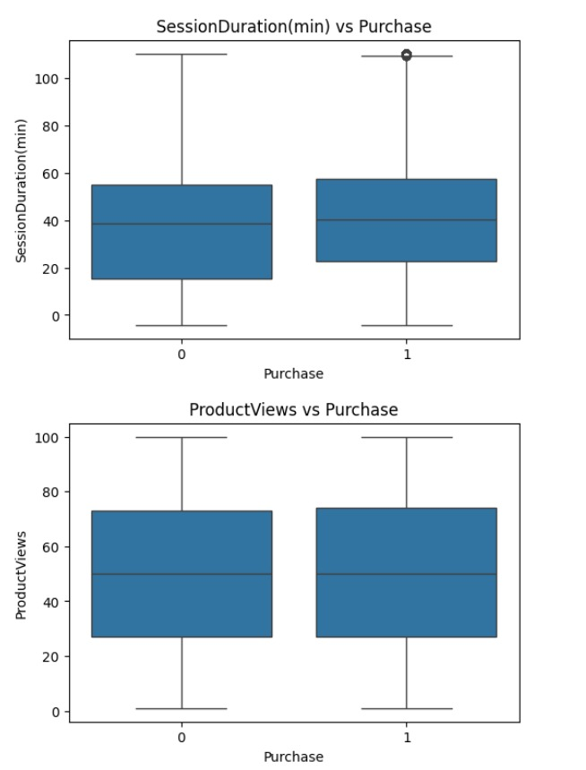

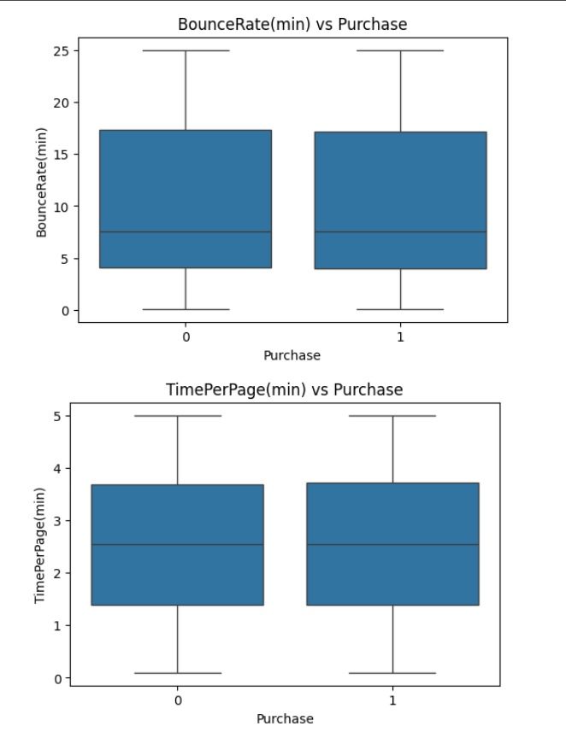
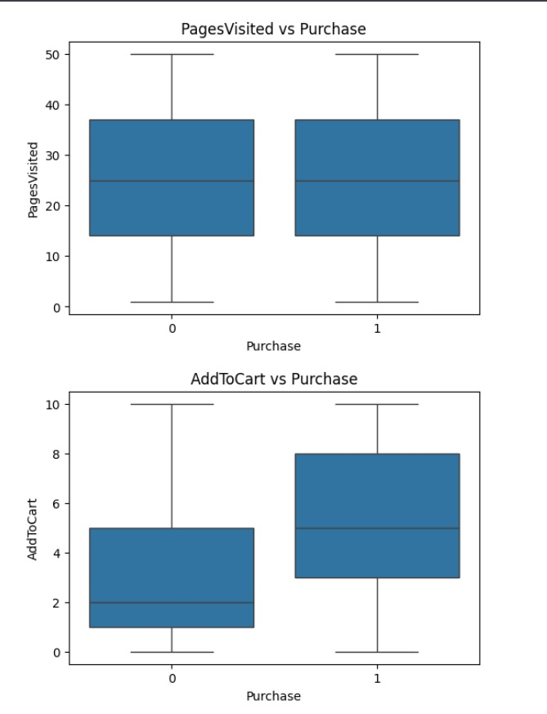

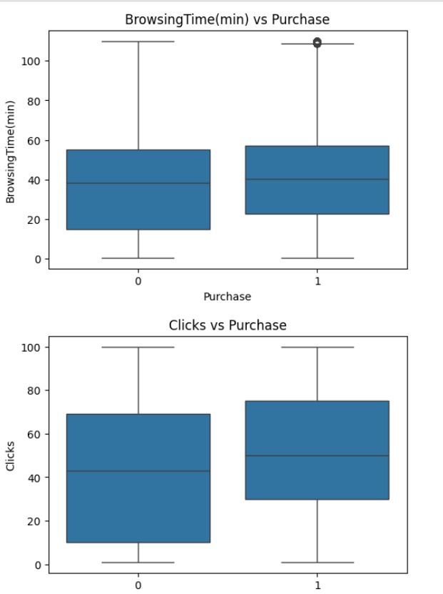
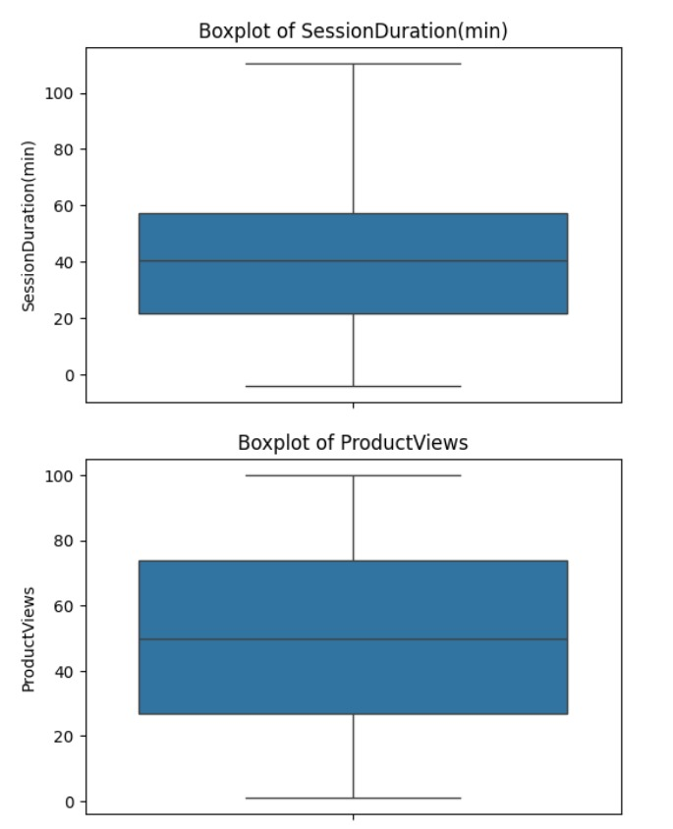

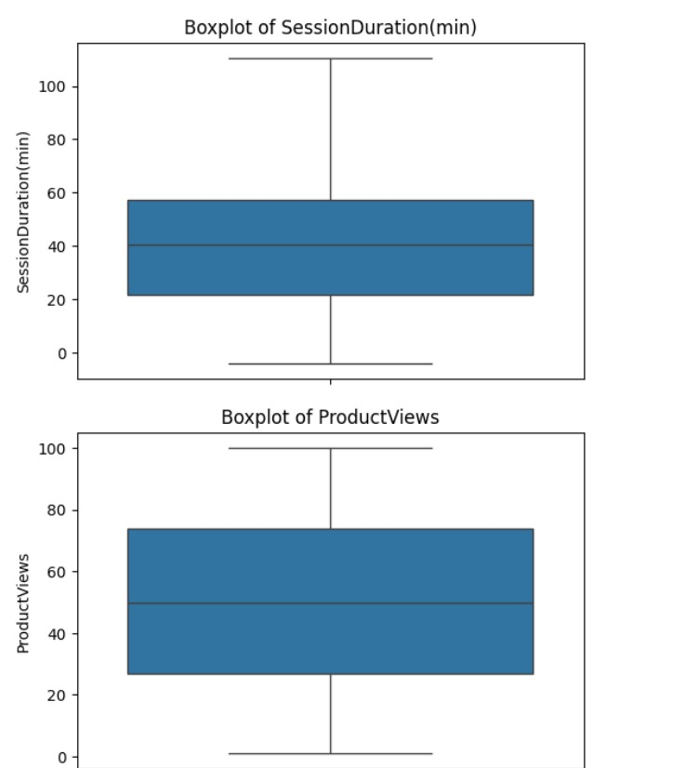
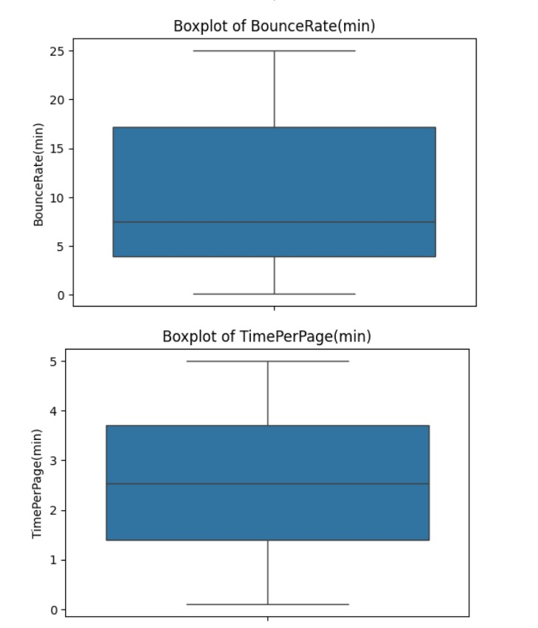

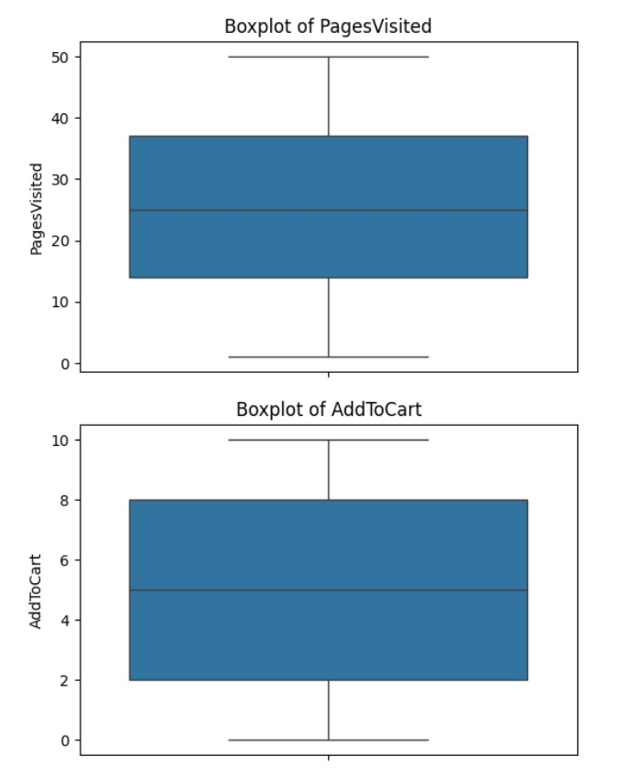

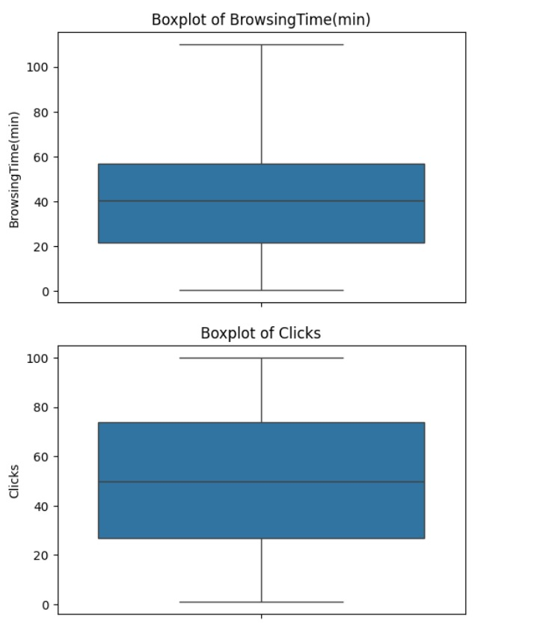

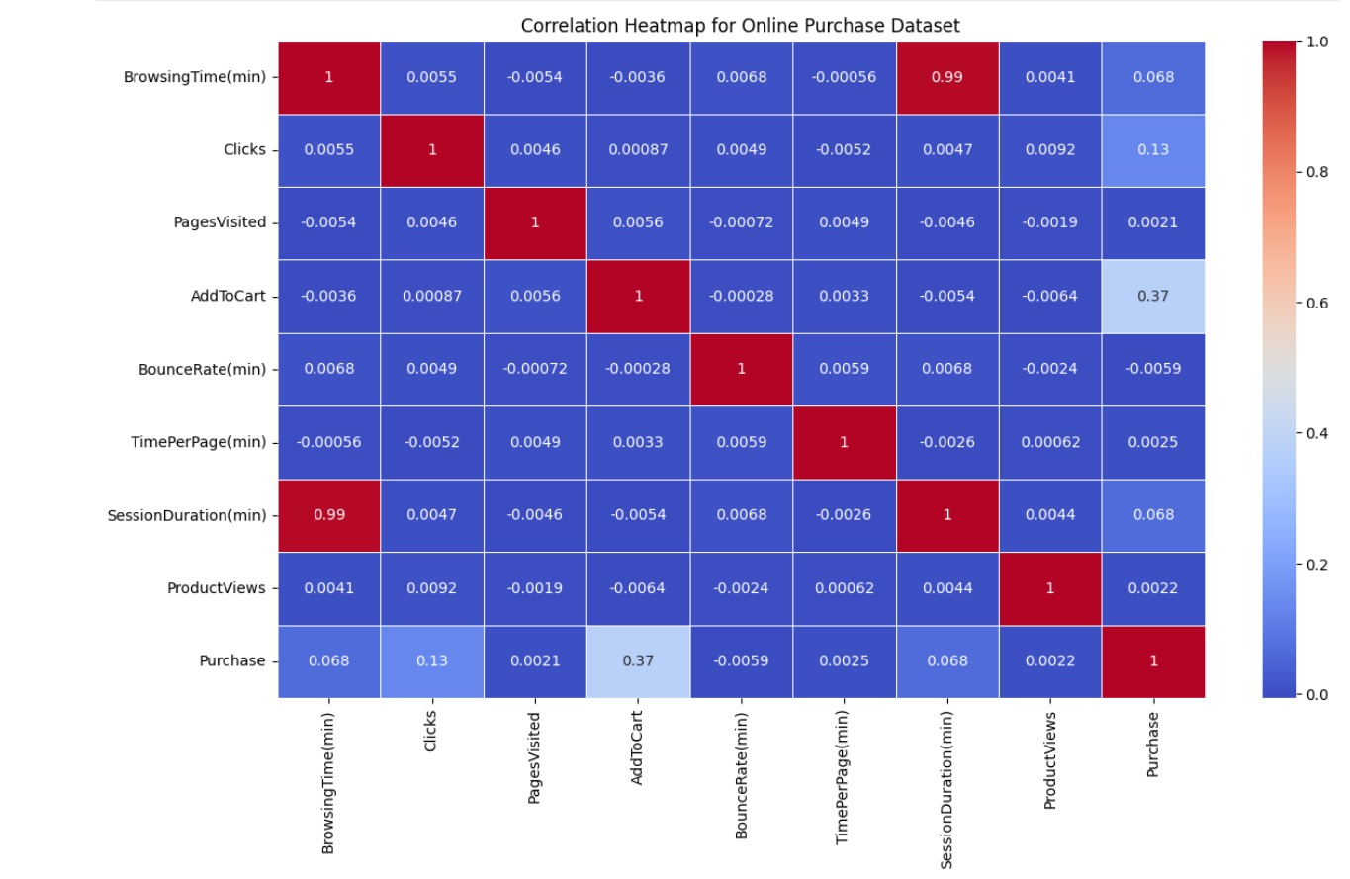

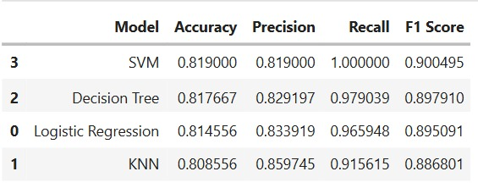

6. REFERENCES:
Books:
- Fundamental of AI and ML Textbook
Online resources:
- Scikit Learn Documentation: scikit-learn.org
- Data Preprocessing and Feature Engineering for Data Mining: www.researchgate.net
- GeeksforGeeks (for reading up various topics of machine learning) : www.geeksforgeeks.org

